# Earnings Beat Estimation: Example of Data Science Application in Python

## Downloading and Installing Python:

Python in itself is a programming language: in addition to installing Python, we will also need various packages and libraries that contain commonly used functions for data analysis. To avoid the burden of configuring our environment from scratch, we will use Anaconda – a pre-packaged installation of python bundled with most of the libraries that we need for data analysis.

1. Go to <https://www.anaconda.com/distribution/#download-section> and download the version of anaconda that matches your operating system

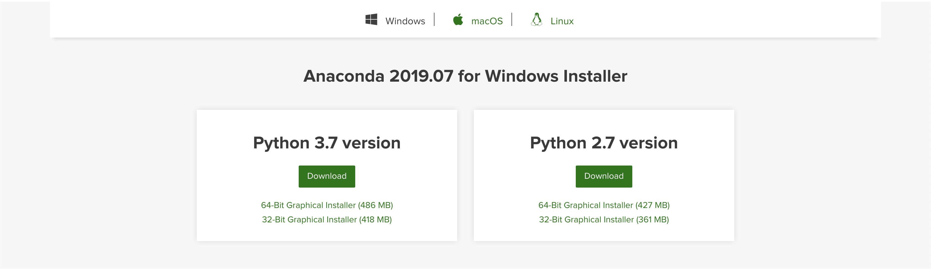

We will use the Python 3.7 Version for our exercise. Most modern computers are 64 bit, so choose the 64-bit graphical installer.

1. Follow the steps in the installer (accept all defaults – you can ignore the section on PyCharm IDE)

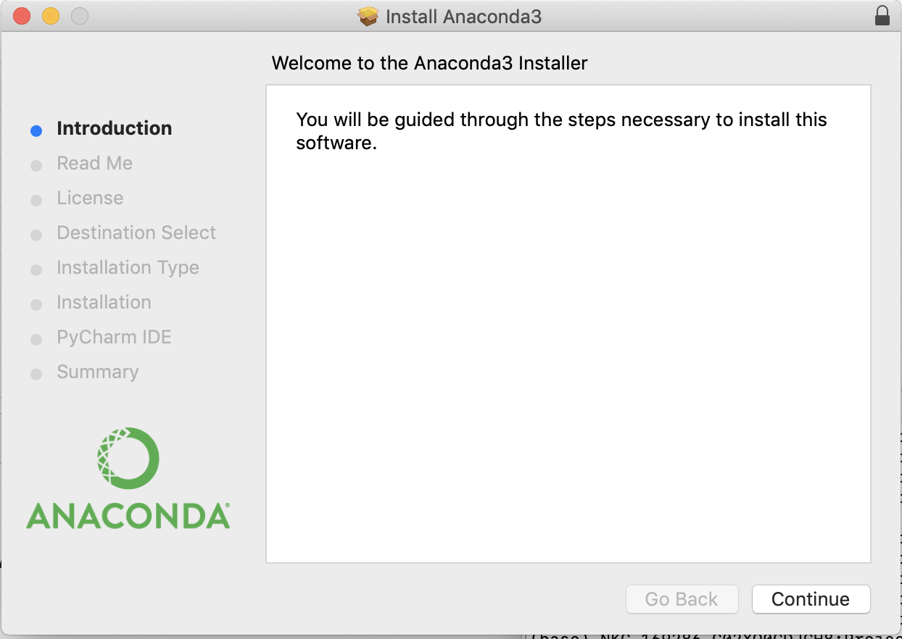

1. Launch Anaconda Navigator and open a Jupyter Notebook Session. This should open in your default browser, giving you an environment to play with data and develop your solution.

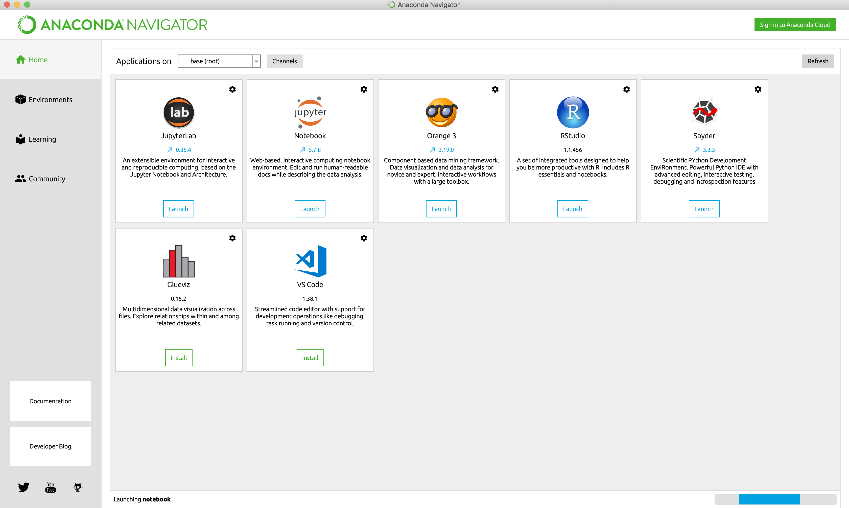

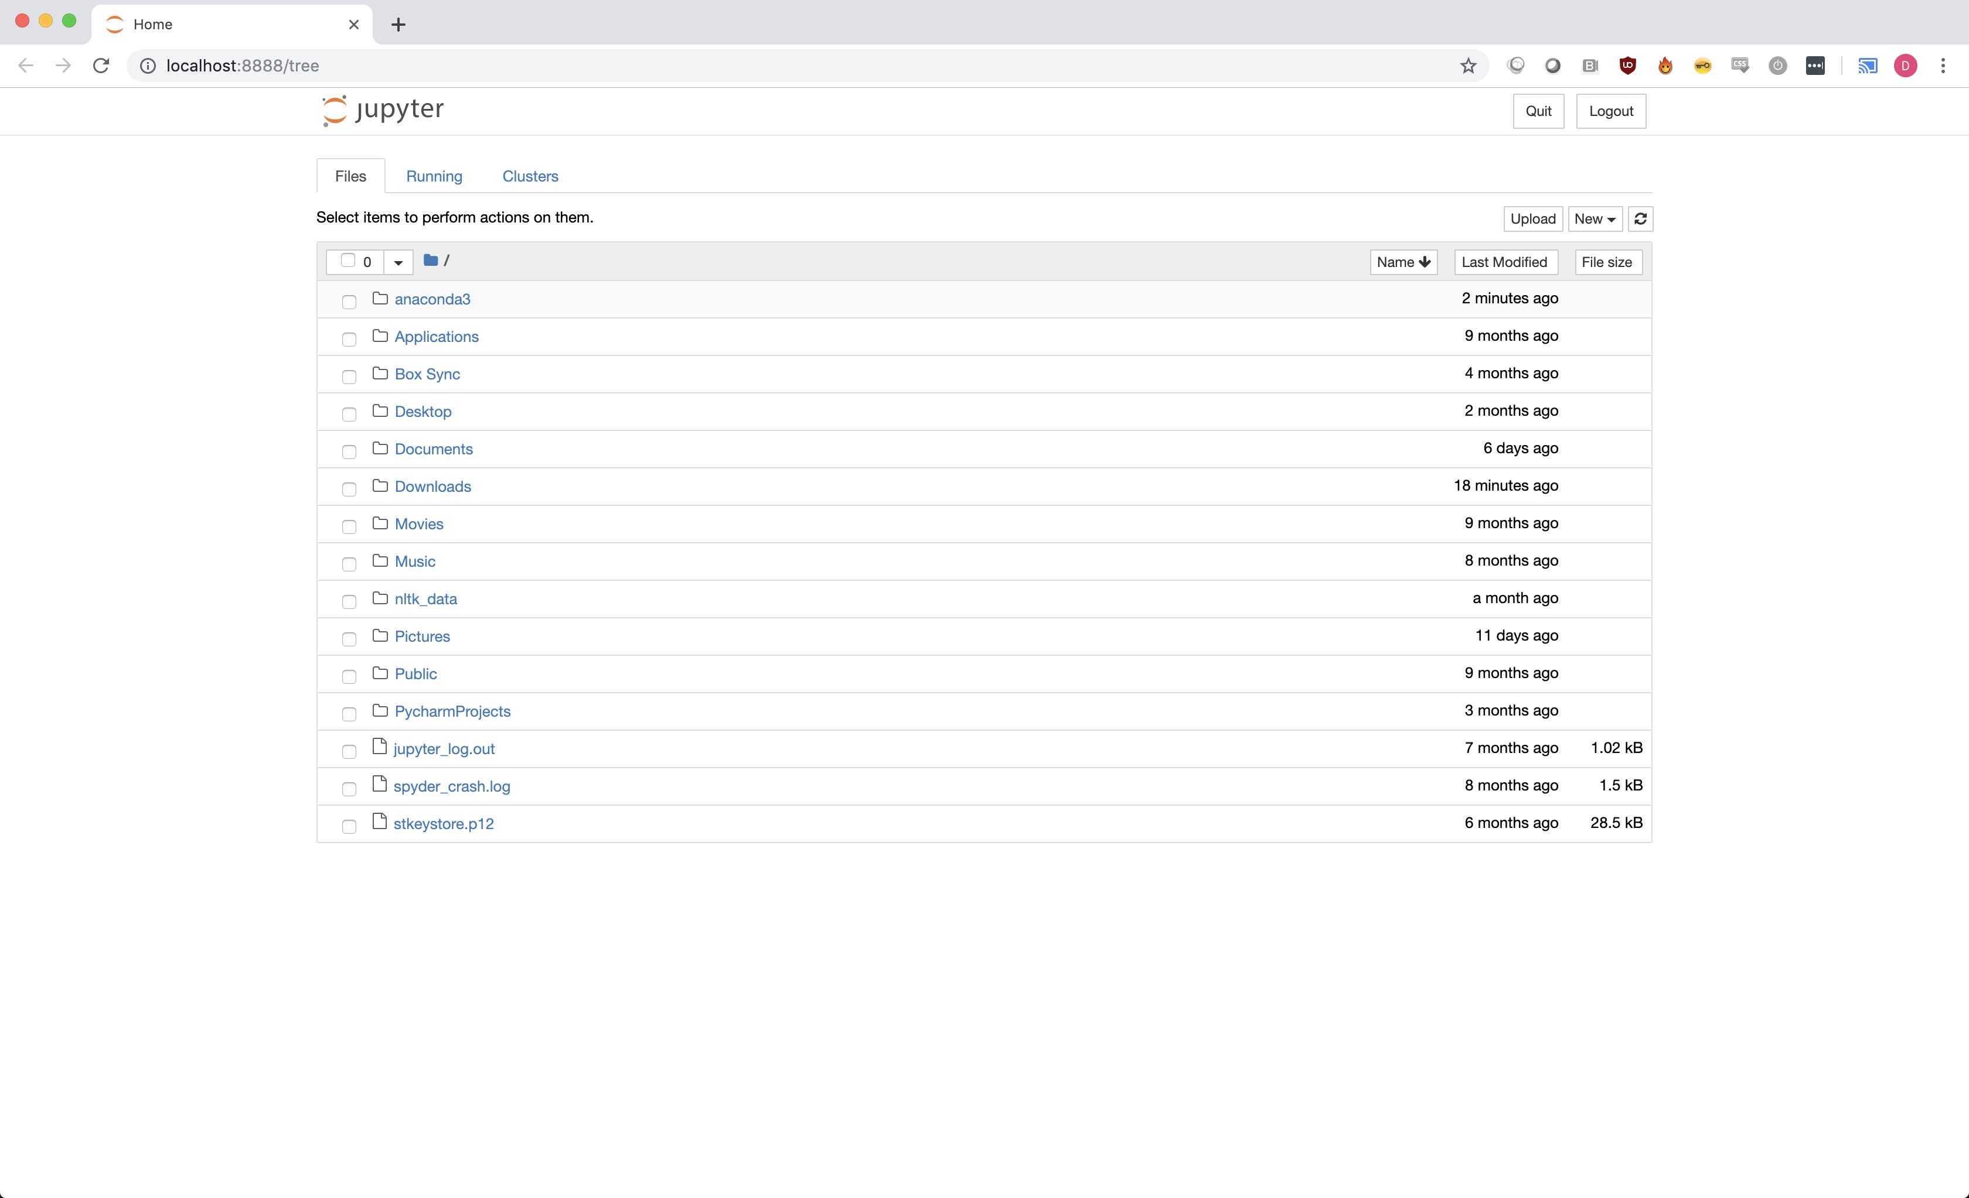

1. Navigate to the directory that has the data you downloaded with the assignment:

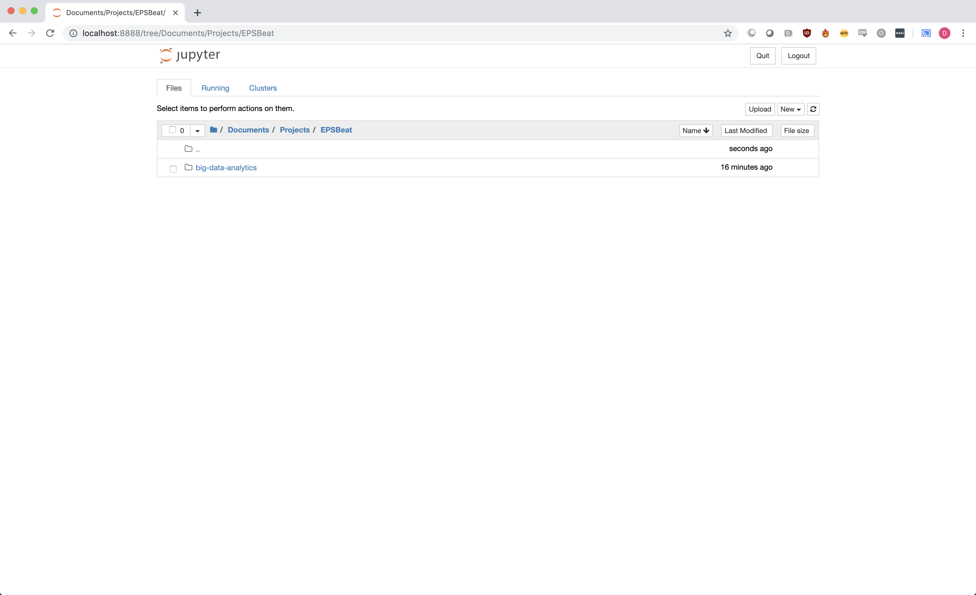

1. Open the notebook Walkthrough Notebook and follow the steps in the notebook.